Docker — Three-Tier Architecture:
- Deploy a three-tier application using Docker Compose: Frontend (Nginx/React) → Backend API → Database (choose MySQL or PostgreSQL).
- Configure Docker networks, persistent volumes, health checks, environment variables, restart policies, and service dependencies. Expose only the frontend externally. Demonstrate how you would troubleshoot frontend → backend and backend → database connectivity issues.
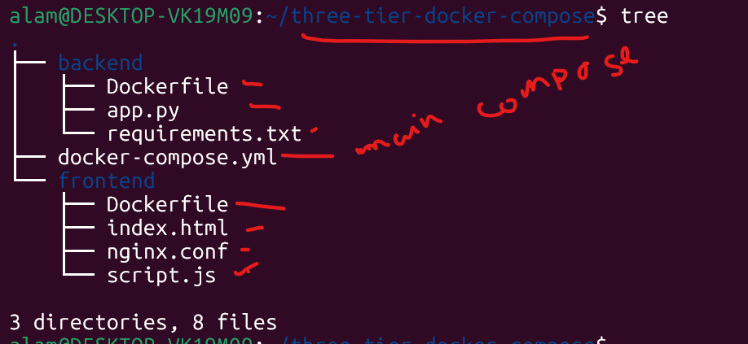

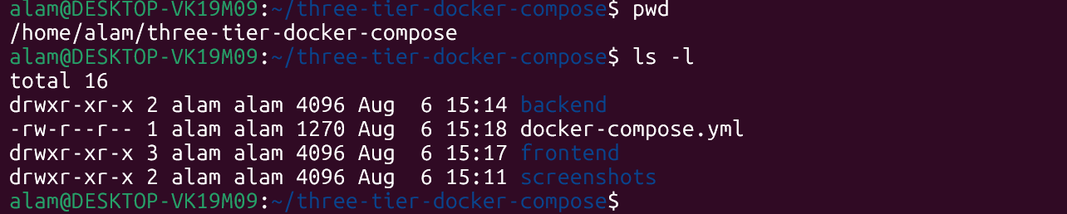
# docker-compose.yml
version: "3.9"

services:

database:

image: mysql:8.0

container_name: mysql-db

restart: unless-stopped

environment:

MYSQL_ROOT_PASSWORD: root123

MYSQL_DATABASE: employee_db

MYSQL_USER: admin

MYSQL_PASSWORD: admin123

volumes:

- mysql-data:/var/lib/mysql

networks:

- three-tier-network

healthcheck:

test: ["CMD","mysqladmin","ping","-h","localhost","-proot123"]

interval: 10s

timeout: 5s

retries: 5

backend:

build: ./backend

container_name: backend-api

restart: unless-stopped

depends_on:

database:

condition: service_healthy

environment:

DB_HOST: database

DB_USER: admin

DB_PASSWORD: admin123

DB_NAME: employee_db

networks:

- three-tier-network

healthcheck:

test: ["CMD","curl","-f","http://localhost:5000/"]

interval: 15s

timeout: 5s

retries: 5

frontend:

build: ./frontend

container_name: frontend

restart: unless-stopped

depends_on:

backend:

condition: service_healthy

ports:

- "80:80"

networks:

- three-tier-network

volumes:

mysql-data:

networks:

three-tier-network:
--------------------------------------------------------------------------------------------------------------------------------------
alam@DESKTOP-VK19M09:~/three-tier-docker-compose/frontend$ ls -l
total 16
-rw-r--r-- 1 alam alam 136 Aug 6 14:39 Dockerfile
-rw-r--r-- 1 alam alam 263 Aug 6 15:15 index.html
-rw-r--r-- 1 alam alam 168 Aug 6 14:39 nginx.conf
-rw-r--r-- 1 alam alam 156 Aug 6 15:16 script.js
alam@DESKTOP-VK19M09:~/three-tier-docker-compose/frontend$ pwd
/home/alam/three-tier-docker-compose/frontend
#cat Dockerfile
alam@DESKTOP-VK19M09:~/three-tier-docker-compose/frontend$ cat Dockerfile
FROM nginx:latest
COPY index.html /usr/share/nginx/html/
COPY script.js /usr/share/nginx/html/
COPY nginx.conf /etc/nginx/nginx.conf

# index.html
alam@DESKTOP-VK19M09:~/three-tier-docker-compose/frontend$ cat index.html
<!DOCTYPE html>

<html>

<head>
<title>Three Tier Docker App</title>
</head>

<body>

<h1>Docker Compose Three Tier Application</h1>

<button onclick="backend()">Check Backend</button>

<p id="result"></p>

<script src="script.js"></script>

</body>

</html>
cat nginx.conf
lam@DESKTOP-VK19M09:~/three-tier-docker-compose/frontend$ cat nginx.conf
events {}
http {
server {
listen 80;
location / {
root /usr/share/nginx/html;
index index.html;
}

location /api {
proxy_pass http://backend-api:5000;
}
}
}

# cat script.js
alam@DESKTOP-VK19M09:~/three-tier-docker-compose/frontend$ cat script.js
async function backend(){
const response = await fetch("/api");
const data = await response.text();
document.getElementById("result").innerHTML=data;
}
-------------------------------- Frontend code over --------------------------------------------------------------------------
--------------------------------------- Backend code start --------------------------------------------------------------------
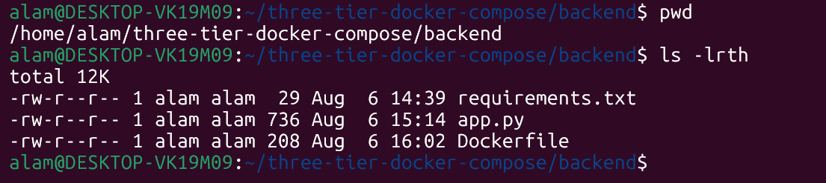
# cat requirements.txt --- file
alam@DESKTOP-VK19M09:~/three-tier-docker-compose/backend$ cat requirements.txt
flask
mysql-connector-python
# cat app.py --- file
from flask import Flask
import mysql.connector
import os
import time

app = Flask(__name__)

db = None

# Retry until MySQL is ready
while db is None:
try:
db = mysql.connector.connect(
host=os.getenv("DB_HOST"),
user=os.getenv("DB_USER"),
password=os.getenv("DB_PASSWORD"),
database=os.getenv("DB_NAME")
)
print("Connected to MySQL")
except Exception:
print("Waiting for MySQL...")
time.sleep(5)

@app.route("/")
def home():
return "Backend API is Running"

@app.route("/database")
def database():
cursor = db.cursor()
cursor.execute("SELECT DATABASE();")
return cursor.fetchone()[0]
app.run(host="0.0.0.0", port=5000)

#cat Dockerfile
lam@DESKTOP-VK19M09:~/three-tier-docker-compose/backend$ cat Dockerfile
FROM python:3.11-slim

WORKDIR /app
COPY requirements.txt .
RUN pip install --no-cache-dir -r requirements.txt

RUN apt-get update && apt-get install curl -y
COPY . .
EXPOSE 5000
CMD ["python","app.py"]

# Buidl every component at once with
#docker compose build
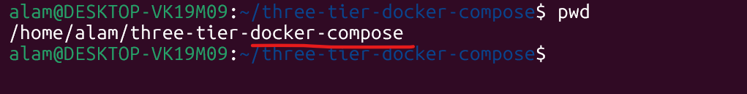

$docker compose build
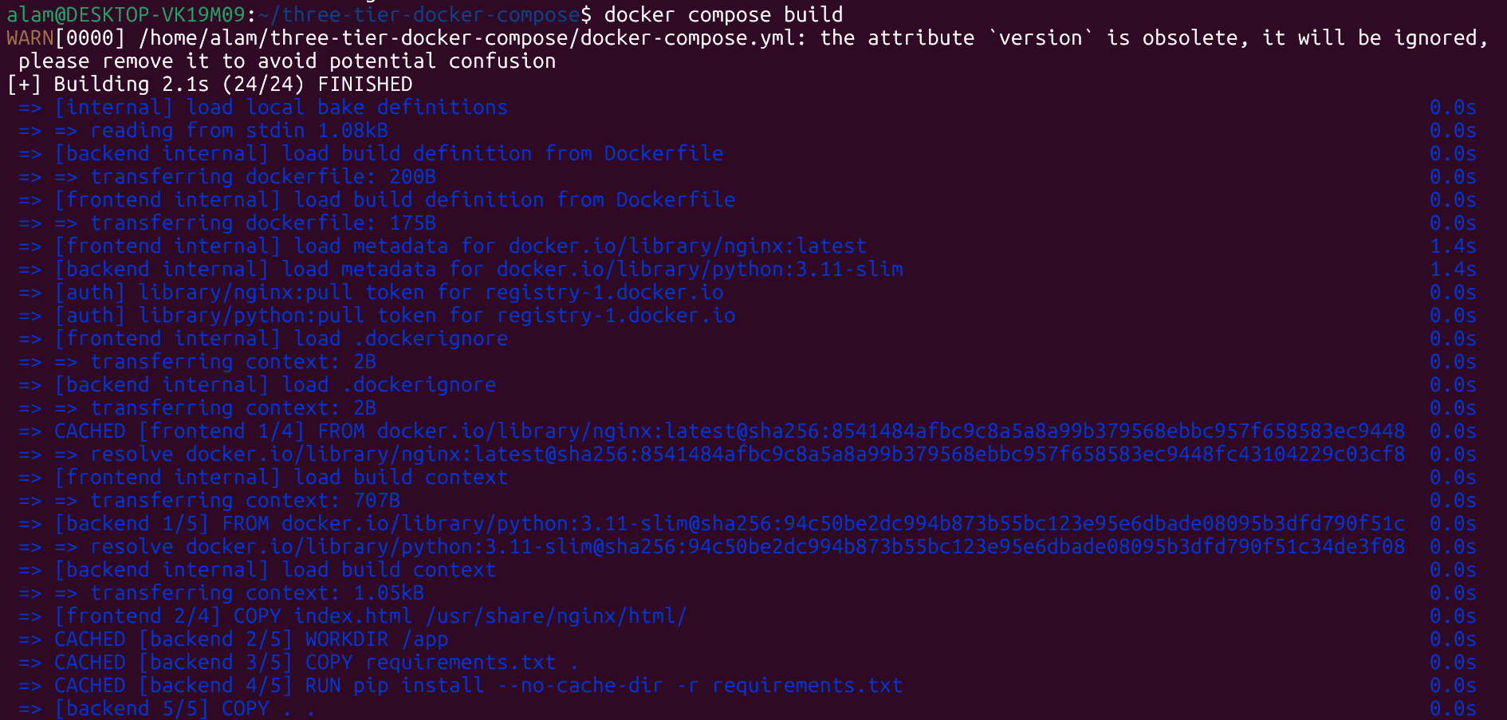
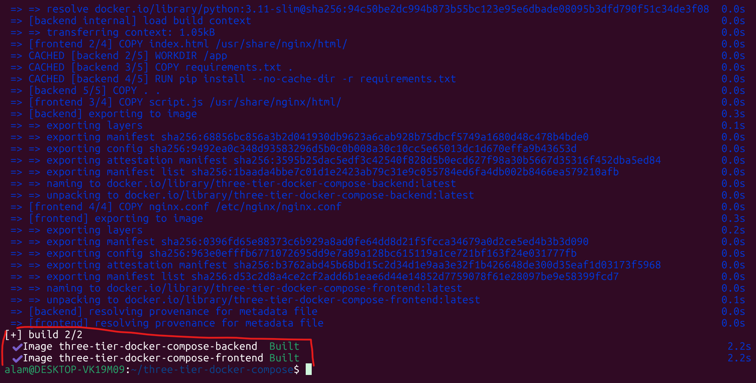
Docker required images created.
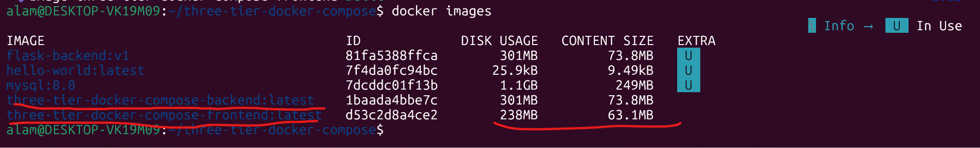
Once images are ready then run
$docker compose up -d
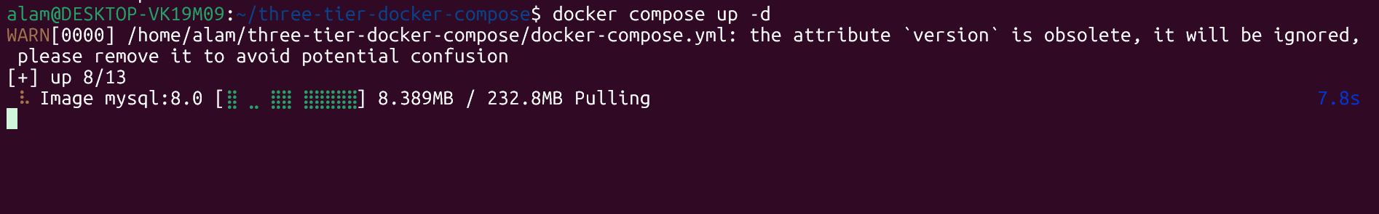
Docker compose up -d ----------worked properly.
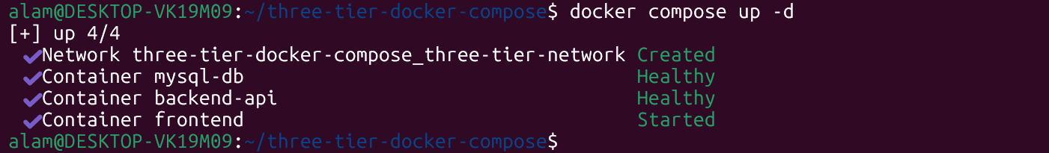
Checking running container
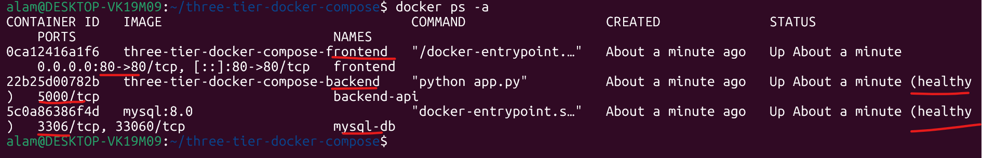

Network & storage status and connectivity check
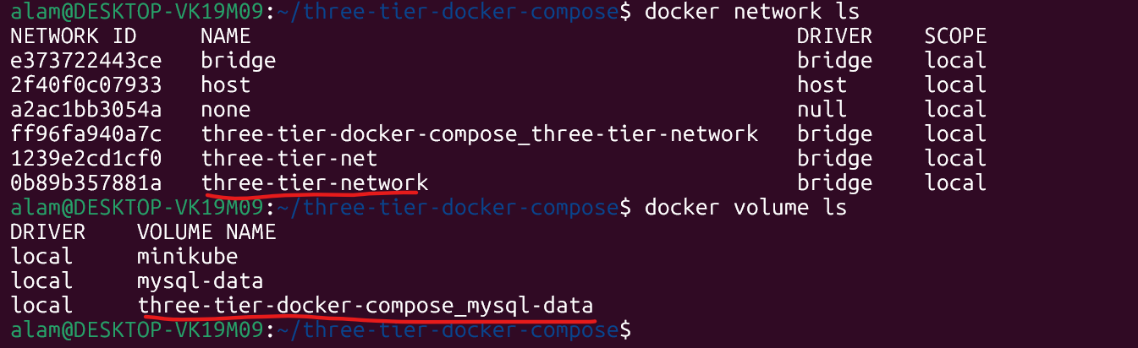
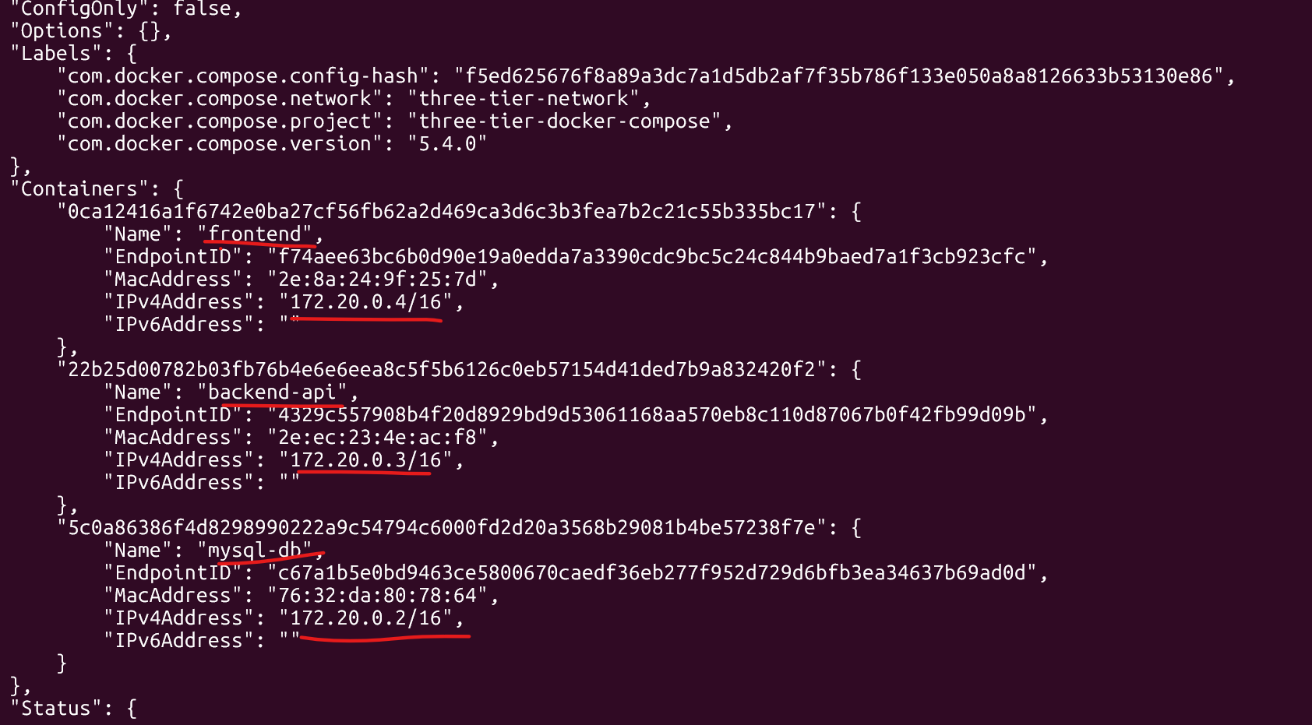
#Check Volume
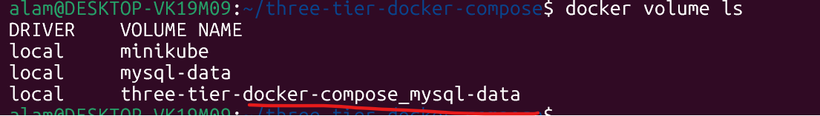
# Browser Test
Frontend chek
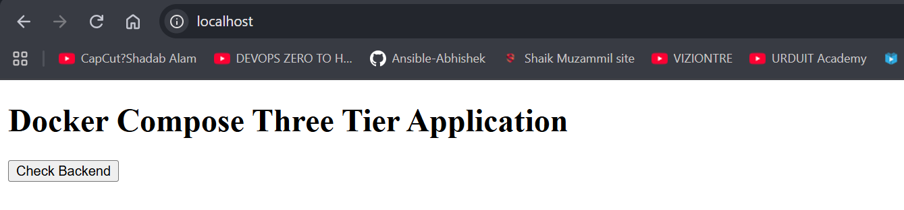

# Database test

#front end to backend connection check
#Backend to backend connection check
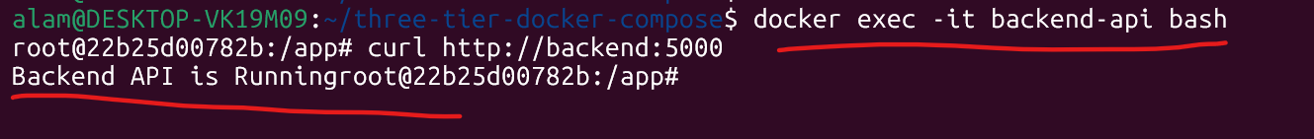
#Backend & frontend to Database connectivity check
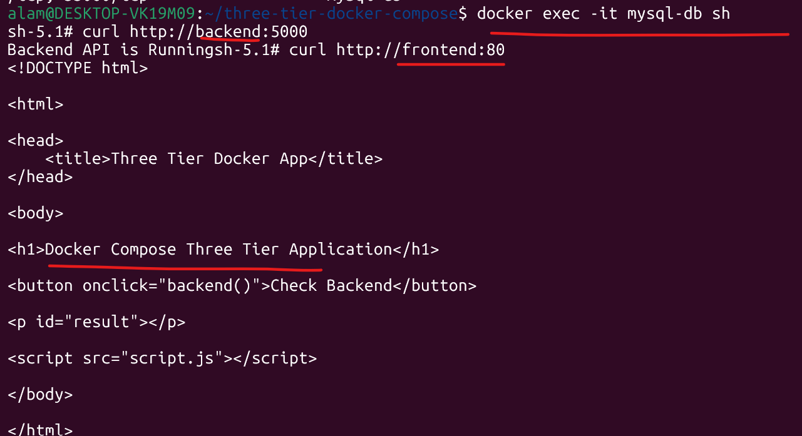

Overall project take away
This project covering the key Docker Compose concepts that are commonly expected in DevOps assignments and interviews: multi-container orchestration, networking, volumes, environment variables, health checks, restart policies, and service dependencies.

